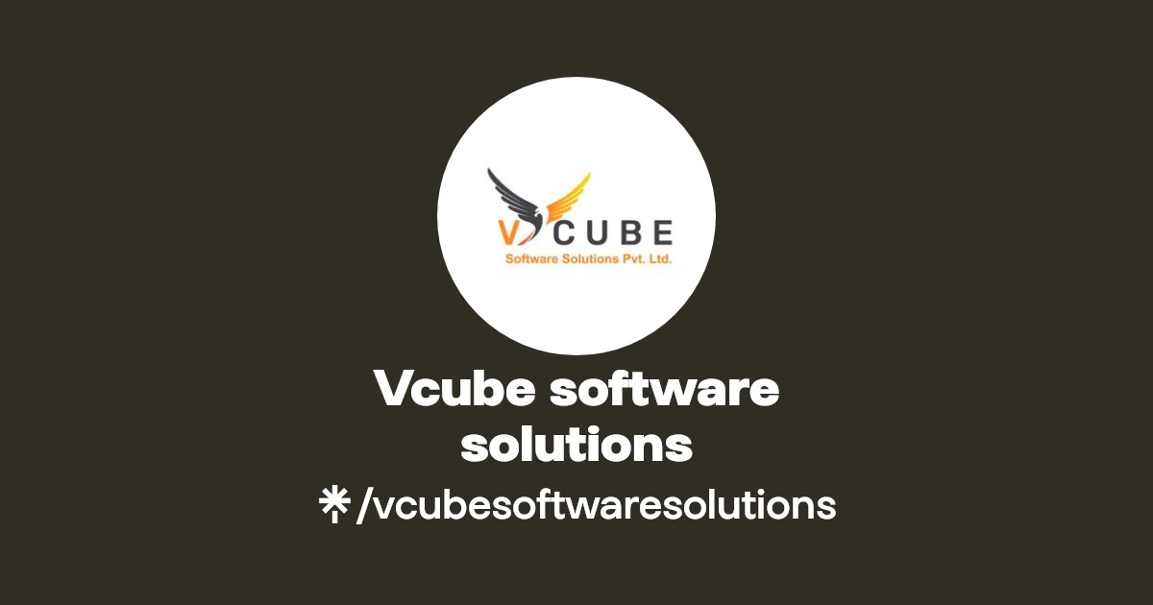

Name :- V. Vamsydhar

Email:- [vamsyvelisetti@gmail.com](mailto:vamsyvelisetti@gmail.com)

Batch :- 122

Lecture By :- K. Madhukar Sir

CREATE AN EFS AND ATTACH IT TO MULTIPLE EC2 INSTANCES

# Elastic File System (EFS) :

* Amazon Elastic File System (Amazon EFS) provides serverless, fully elastic file storage so that you can share file data without provisioning or managing storage capacity and performance.
* Amazon EFS is built to scale on demand to petabytes without disrupting applications, growing and shrinking automatically as you add and remove files. Because Amazon EFS has a simple web services interface, you can create and configure file systems quickly and easily.
* The service manages all the file storage infrastructure for you, meaning that you can avoid the complexity of deploying, patching, and maintaining complex file system configurations.

# Creating an EFS :

* To create an EFS first we should create a Security group with our protocols.
* After creating the security group go to EFS and select on customise when creating the EFS.

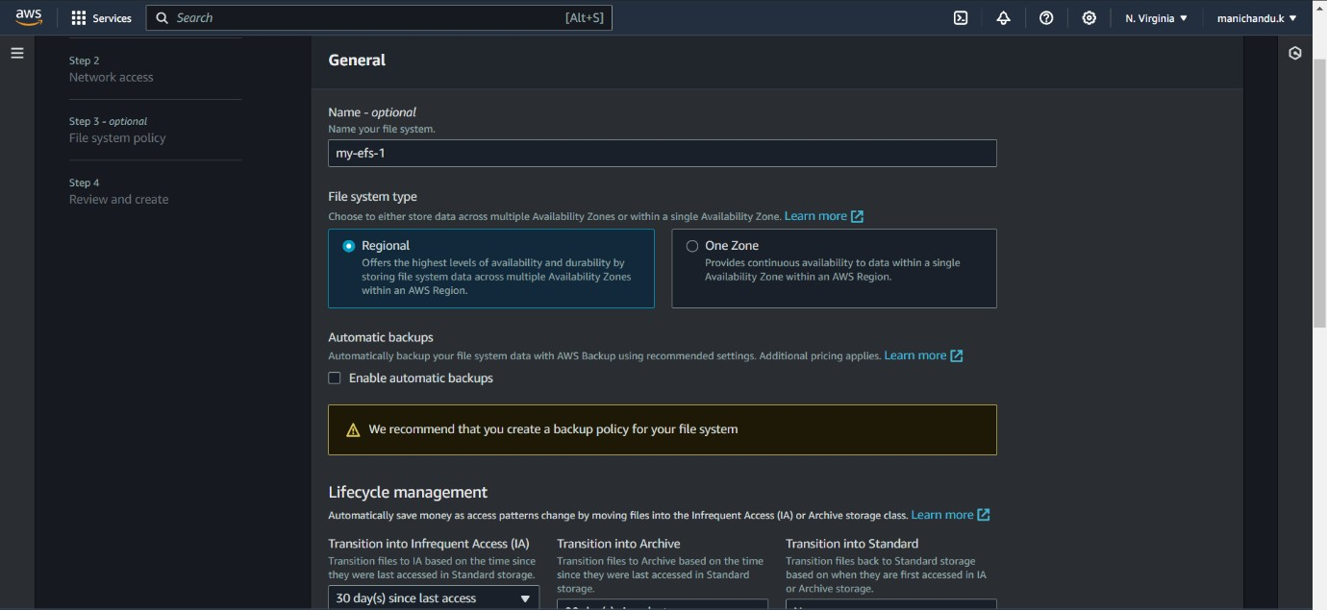

* Select regional option to connect to instances in other regions also.
* You can configure the life cycle management to reduce the cost of EFS.
* Now upon clicking next you will gon to step 2 – Network access where you can select in which VPC you would create the EFS and in which region will it be available
* Select the security group for these zones which we created before.

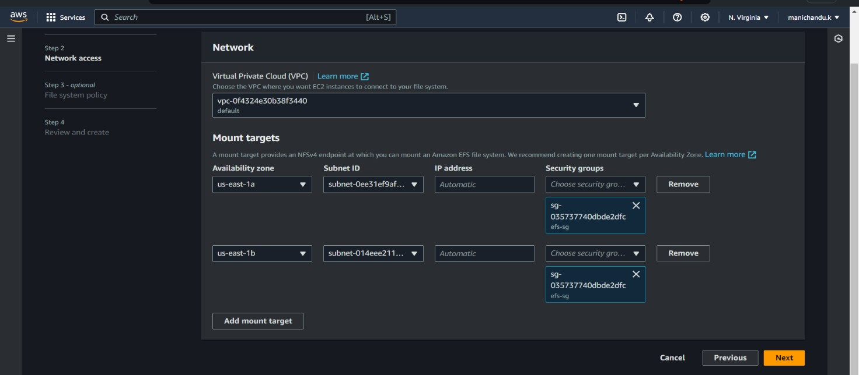

* Click on next and go to review and create the EFS.
* After creating the EFS go to EC2 instances and launch an instance in a zone where we have given EFS.

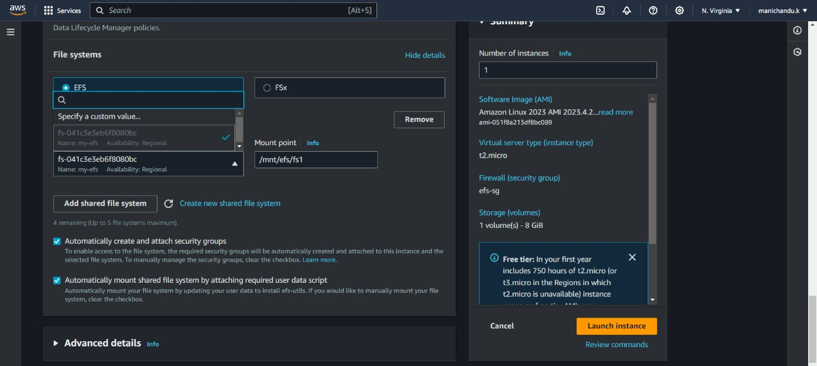

* While launching the EC2 instance give the security group which we created first and click on configure storage.
* Now click on file systems and click on add shared file system and select our file system. Now launch the instance.
* Now repeat the process with another instance in another zone which we gave access to EFS.
* Now connect to both instances and and give the disk command df -h
* You will see an filesystem named 127.0.0.0/…. mounted on

/mnt.efs/fs1 which we gave earlier in instance configuration.

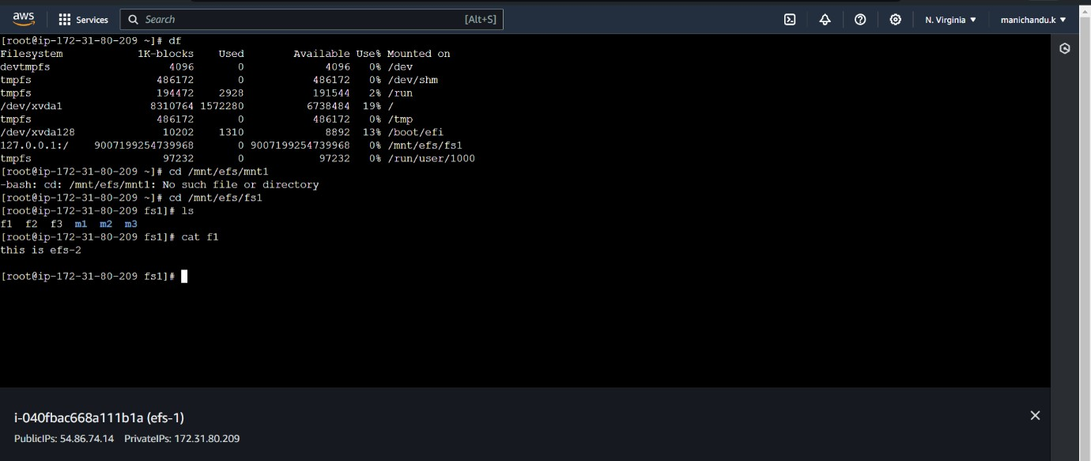

* Now cd to the mount path of EFS and create files and directories in that directory.
* Now connect to another instance and cd to the same path and list the files and directories.
* You can access the files and even the data in files in the other instance from here.

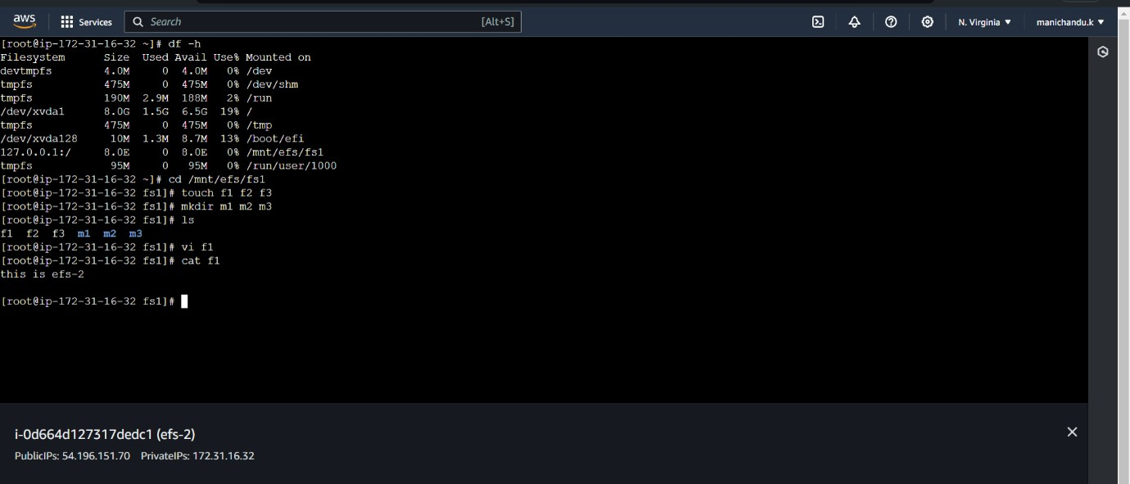

* Your EFS is successfully created and attached to two different instances in two different zones.

**THE END**